**TABLE: HOSPITAL**

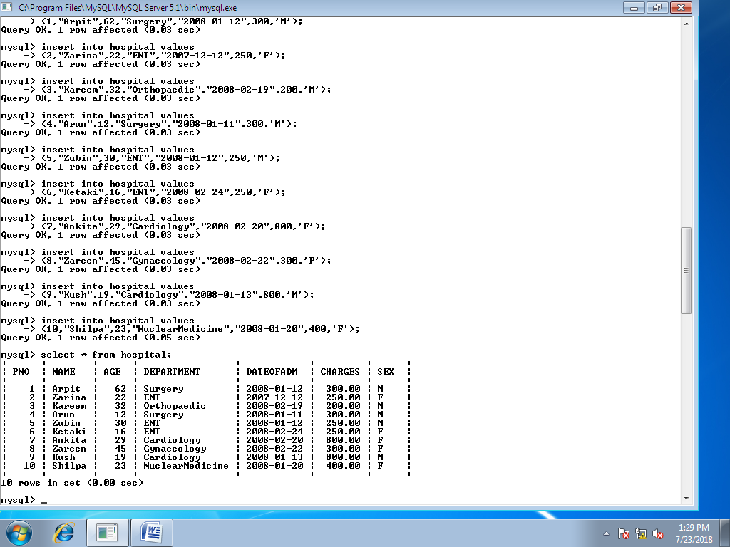

**Queries:**

1. Write the command to describe the structure of the above table.
2. To select all the information of patients of cardiology department.
3. To list the names of all female patients who are in ENT department.
4. To list the names of all female patients with their date of admission in ascending order.
5. To display patients’ name,charges,age of only female patients.
6. To count the number of patients with age<30.
7. To display the department wise total charges.
8. To display the department wise total charges whose maximum charges more than or equal to 300.
9. Add one more column Address of type char(20).
10. Modify the column Address as char(25).
11. Change the name of the column Address to Home_address.
12. Drop the column Home_address.

1.

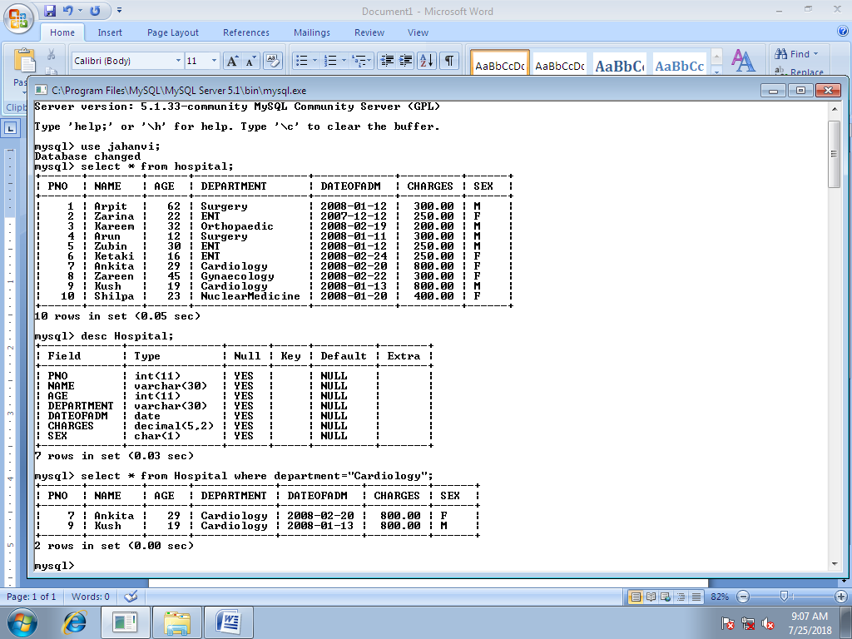

2.

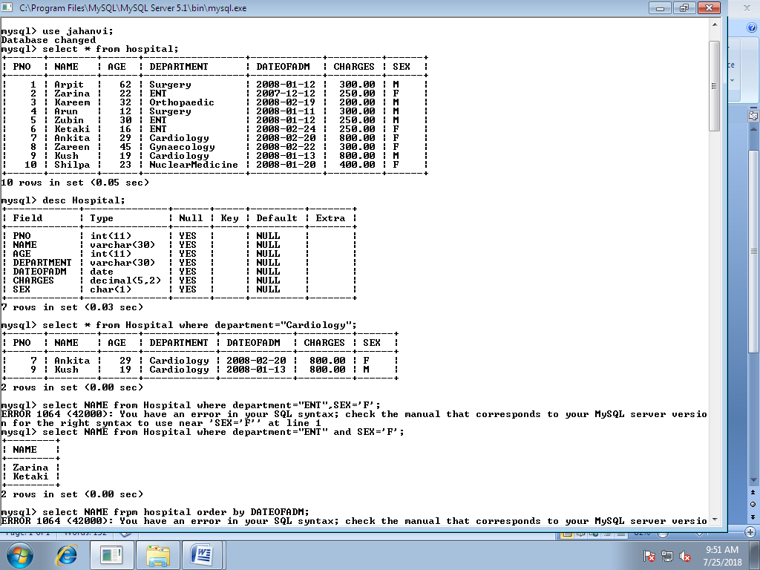

3.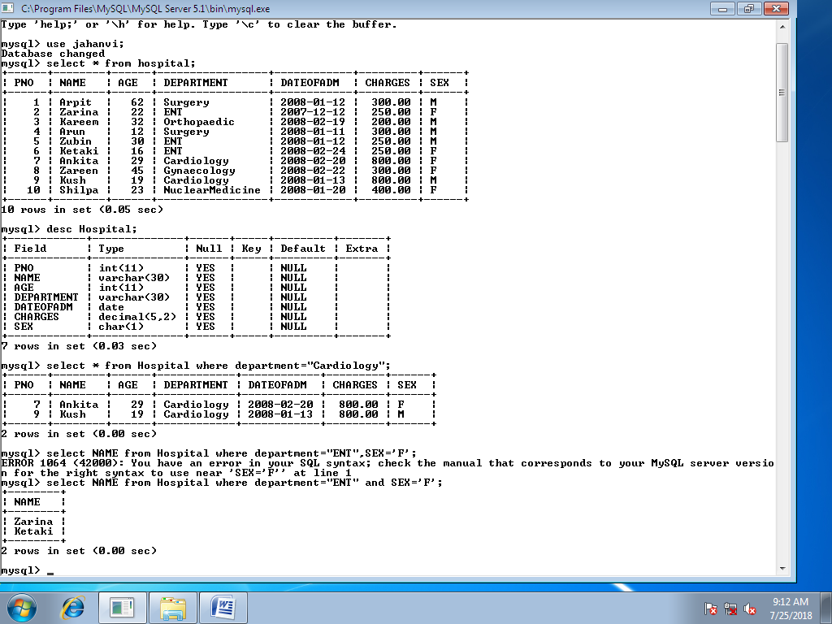

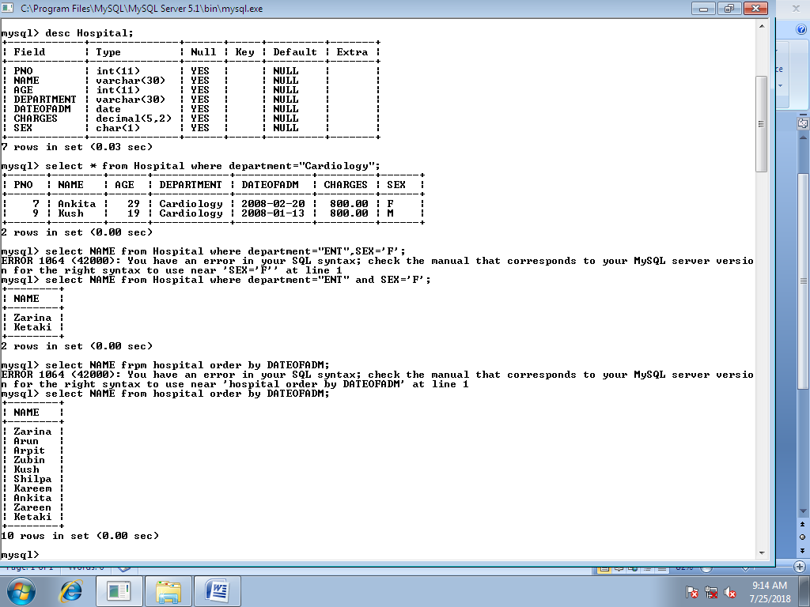4.

5.

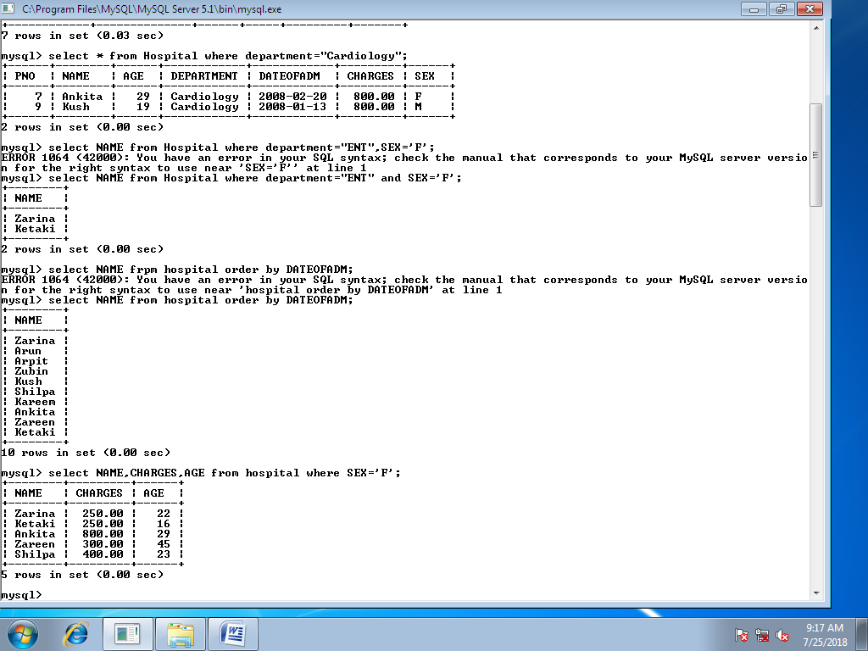

6.

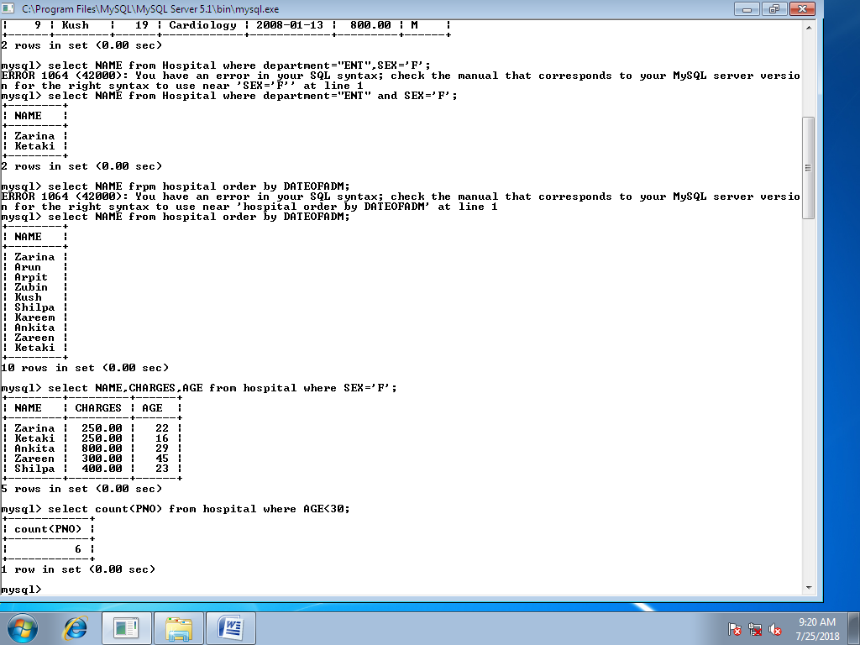

7.

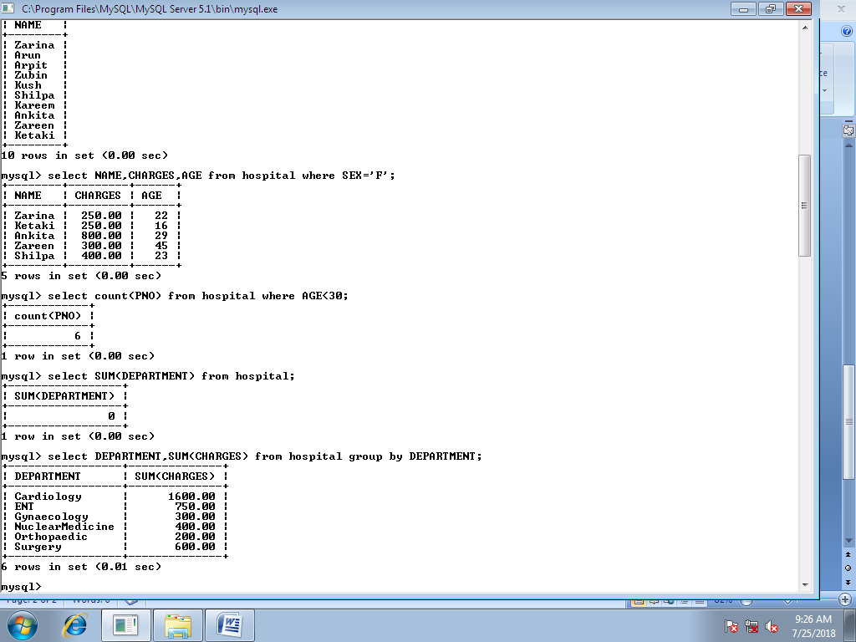

8.

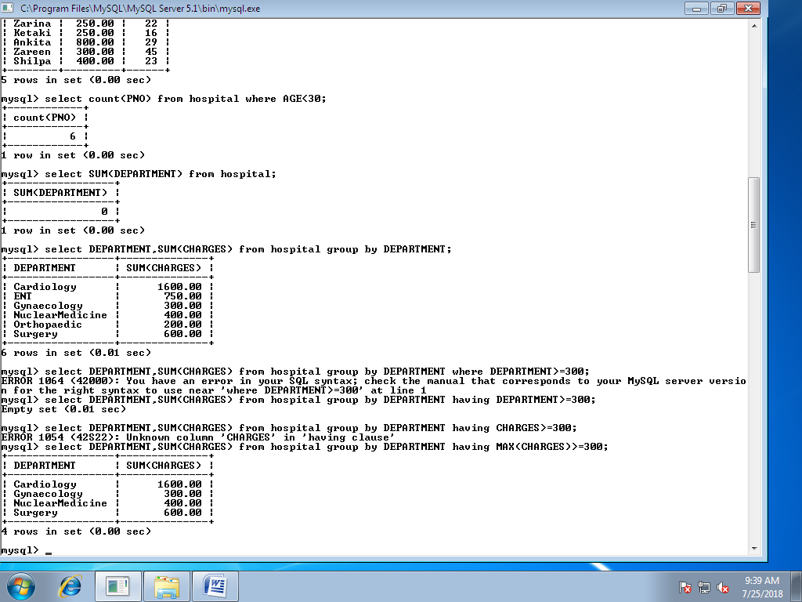

9.

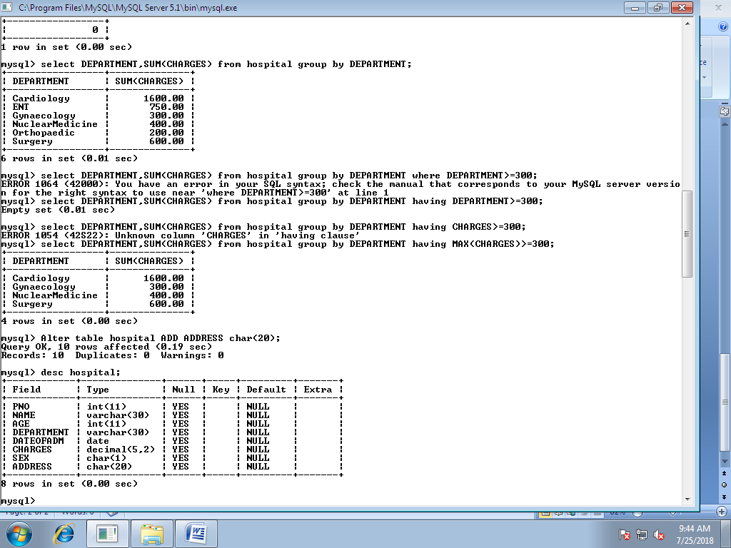

10.

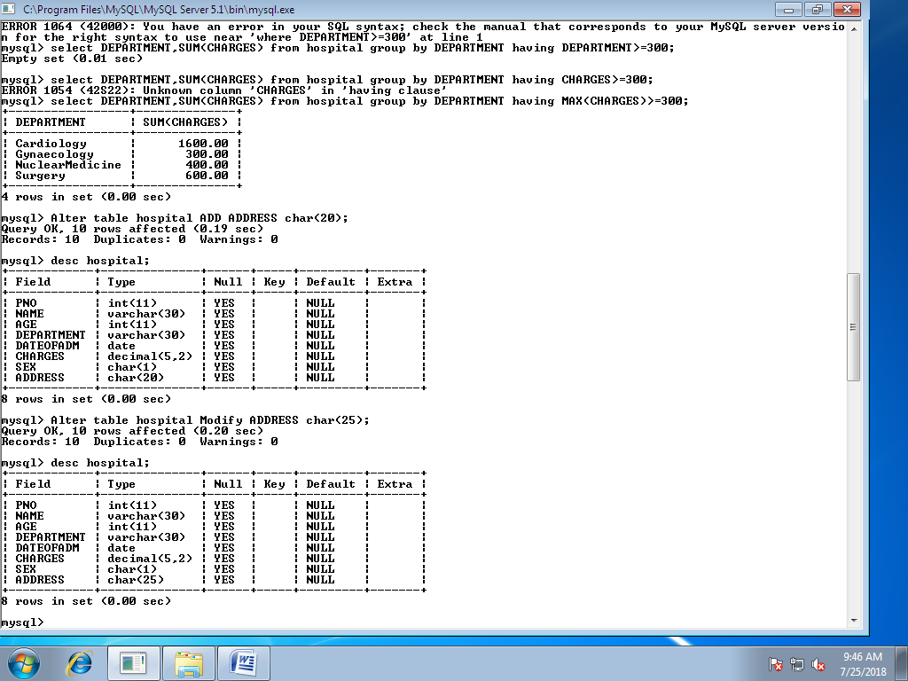

11.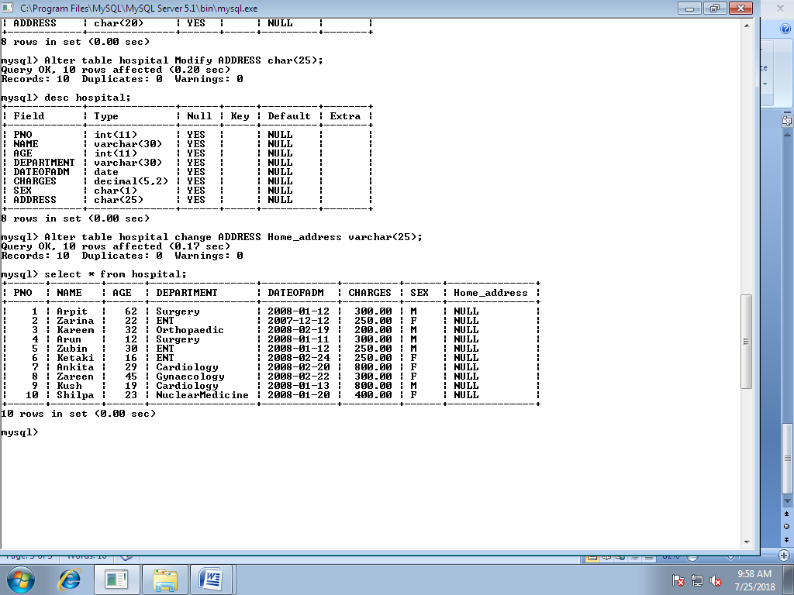

12.